**Abstract:-**

The goal of this project is to build an "online MCQ exam." Through this project, staff members and administrators can conduct an online exam, answer exam questions, and view the result list. Users must first register before they can log in, take the exam, and receive their results right away. Full stack languages, such as HTML, CSS, JavaScript, PHP, MySQL, and others, will be used to construct this project.

**Project Modules:-**

* Admin/Staff login: - In this module using user name and password admin can login.
* Manage Test :- In this module admin can manage the test (add or delete)
* Manage question and answer: - In this module admin can add or delete question and answer.
* View result: - In this module admin can view the result.
* User/Student registration: - In this module user can register with his details.
* User login: - using username and password user can login.
* Submit test :- In this module user can submit the test and get the result.

**Literature survey:-**

* **Existing system:** - According to my survey, some institutes administer the test manually because there is no online software available. As a result, they spend more time manually preparing the test materials.
* **Proposed System: -** The goal of this project is to build an "online MCQ exam." Through this project, staff members and administrators can conduct an online exam, answer exam questions, and view the result list. Users must first register before they can log in, take the exam, and receive their results right away. Full stack languages, such as HTML, CSS, JavaScript, PHP, MySQL, and others, will be used to construct this project.

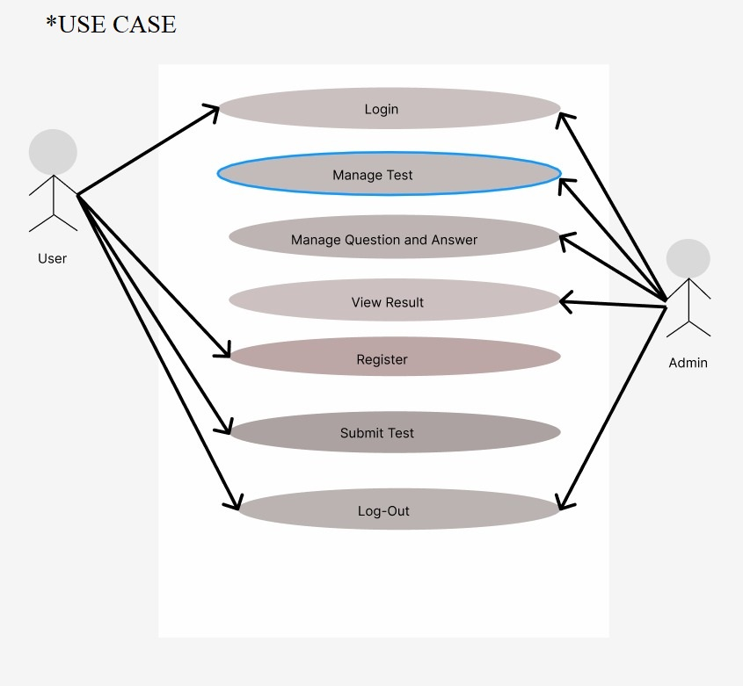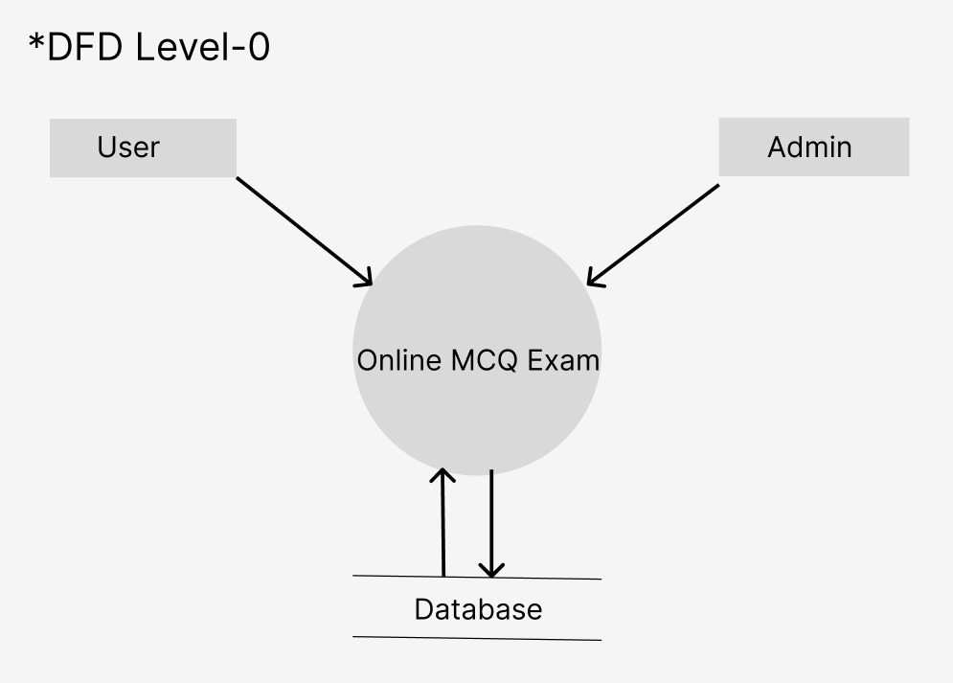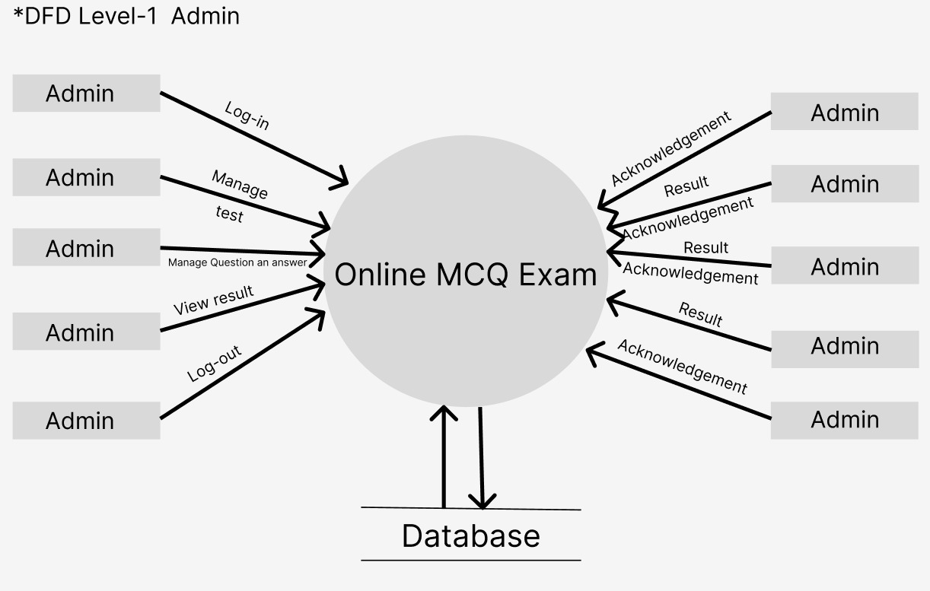

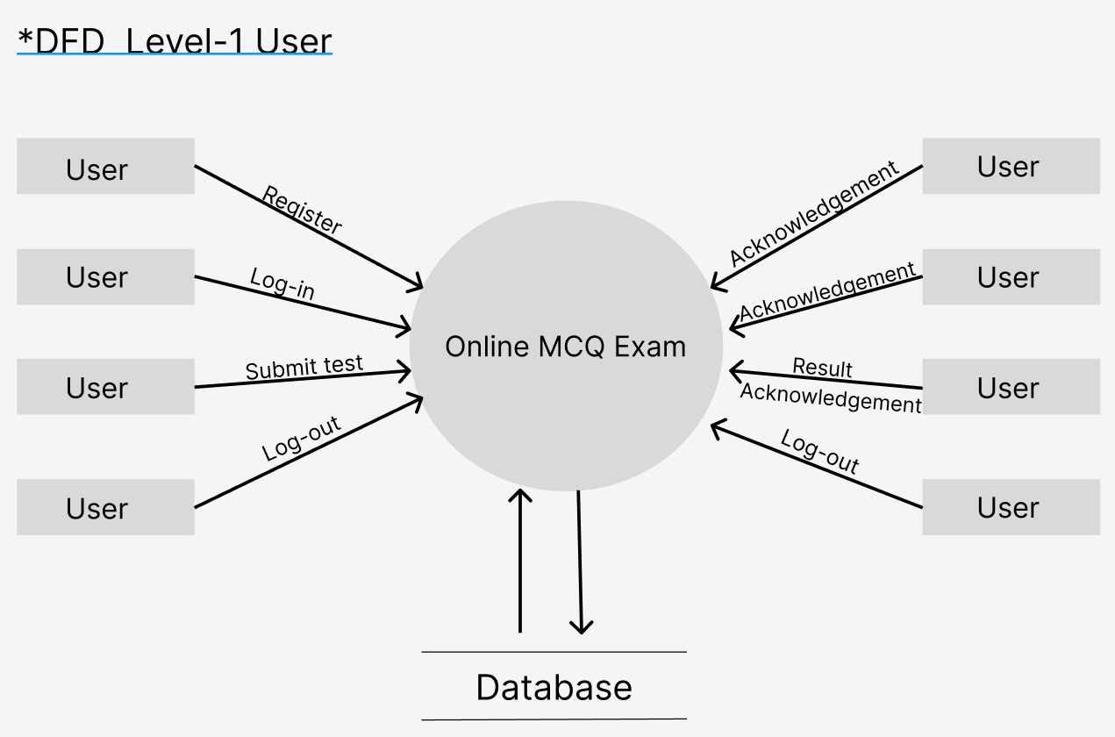

**Requirements**

**Requirements for developing:-**

* Average I3 processor.
* Average 4GB RAM.
* Average 512GB hard disk.

**Hardware requirement for deployment:-**

* Average I3 processor.
* Average 2GB RAM.
* Average 256GB storage.

**Software requirement for development:-**

* OS (Window’s, MAC, Linux).
* XAMP Server.
* VS Code.
* Chrome.

**Software requirement for deployment:-**

* OS.
* Chrome.

**Language used or technology:-**

* Content language (client side language) (HTML, CSS, Bootstrap, JavaScript).
* Backend (server side language) (PHP).
* Database (MySQL).

**Advantages:-**

1. Reduce the time of user.
2. Reduce the manual work.
3. Easy to use.
4. Access from any location.
5. Student can submit online test and get result easily.

**Future Scope:-**

* We can live the project to any institute.
* We can develop the mobile application.

**Conclusion:-**

Admin/staff login, Manage test, Manage question and answer, View result, User/student registration, User login, Submit test, and error-free and user-friendly are all modules we will implement for Online MCQ Test in accordance with the summary.

**BIBLIOGRAPHY:-**

**Books:-**

[1] “Web Programming”, by ‘Chris Bates’ Wiley Dreamtech India, 2nd Edition.

[2] “Software Engineering”, Ian Somerville, Sixth Edition, Pearson Education Ltd.

[3] “HTML Complete References” Easy steps to develop web pages.

[4] “PHP Complete Reference”

**Websites:-**

[1] [http://en.wikipedia.org/wiki/**PHP**](http://en.wikipedia.org/wiki/PHP)for Php.

[2] [http://www.hotscripts.com/category/**php**/](http://www.hotscripts.com/category/php/) for Php

[3] [http://www.**mysql**.com/click.php?e=35050](http://www.mysql.com/click.php?e=35050) for MySQL.

[4] [http://www.w3schools.com](http://www.w3schools.com/) for information on HTML.